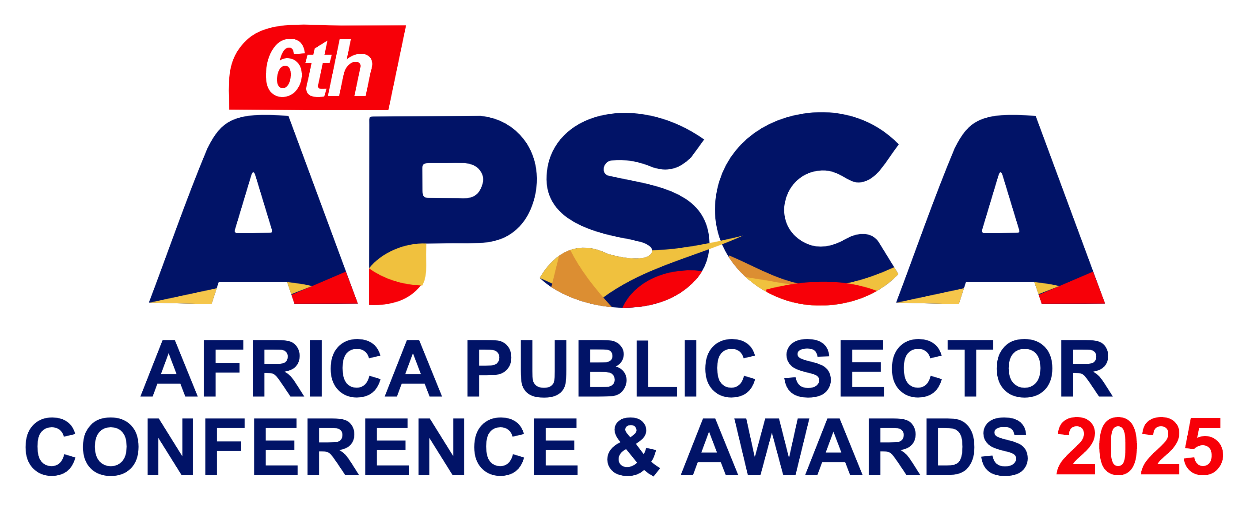

Entry Form

PART A

Company Details
Company Name
Company Address
Contact Person
Contact Details
Submission Details
Item | Details
Tick Submission Award Categories
Declaration  I guarantee that the information provided is true and correct at the point of submitting this entry.  Notes:  - Please ensure your form has been emailed to anaphtal@instinctwave.com  - Please fill one form for each category entered. |  | ………………………………….  Authorised Signatory
There are several general sponsorship options available if you would like to find out more about our sponsorship opportunities. Please get in touch with Akin Naphtal – anaphtal@instinctwave.com for further information.

PART B

Award Snapshot
(Please describe in between 500 – 1000 words why your executive Agency or ministry should win the chosen category. Please refer to the bullet points below the category when outlining your rationale.) Graphs and pictures can be copied into this document.
Website URL | https://africapublicsector.com/
Any other details you wish to share
Please send this form & any supporting documents to anaphtal@instinctwave.com

